2012

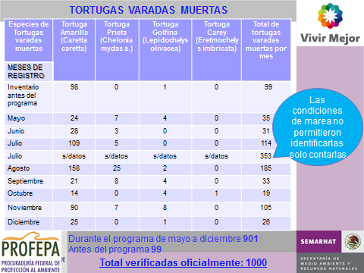

2013

|  |  |  |  |  |  |  |  |  |
| --- | --- | --- | --- | --- | --- | --- | --- | --- |
| **MES** | **AMARILLA** | **PRIETA** | **GOLFINA** | **CAREY** | **AMARILLAS VIVAS** | **PRIETAS VIVAS** | **GOLFINAS VIVAS** | **TOTAL** |
| **ENERO** | **6** | **0** | **1** | **0** | **0** | **0** | **0** | **7** |
| **FEBRERO** | **5** | **1** | **1** | **0** | **0** | **0** | **0** | **7** |
| **MARZO** | **23** | **1** | **0** | **0** | **0** | **0** | **0** | **24** |
| **ABRIL** | **65** | **3** | **1** | **0** | **3** | **0** | **0** | **72** |
| **MAYO** | **104** | **7** | **2** | **1** | **0** | **0** | **0** | **114** |
| **JUNIO** | **74** | **10** | **0** | **0** | **1** | **1** | **0** | **86** |
| **JULIO** | **188** | **20** | **3** | **1** | **0** | **0** | **0** | **212** |
| **AGOSTO** | **136** | **36** | **6** | **0** | **0** | **0** | **0** | **178** |
| **SEPTIEMBRE** | **75** | **25** | **9** | **0** | **0** | **0** | **0** | **109** |
| **OCTUBRE** | **56** | **13** | **12** | **0** | **0** | **0** | **0** | **81** |
| **NOVIEMBRE** | **15** | **1** | **2** | **0** | **0** | **0** | **0** | **18** |
| **DICIEMBRE** | **9** | **0** | **1** | **0** | **0** | **0** | **0** | **10** |
|  |  |  |  |  |  | SIN DEFINIR | | 1 |
|  | **756** | **117** | **38** | **2** | **4** | **1** | **0** | **919** |

2014 