U.S. Department of the Interior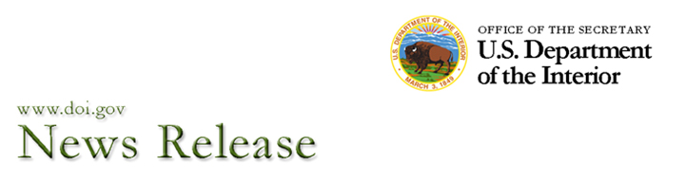
Date: August 11, 2009
Contact: Joan Moody (DOI) 202-208-6416
Alejandro Posados (SEMARNAT) 202-728-1777 .

U.S. Secretary of the Interior Ken Salazar and Mexican Minister of Environment and Natural Resources Juan Elvira Decide to Strengthen Conservation Cooperation in Big Bend Area of the U.S. - Mexico Border
Washington, D.C. and Mexico, D.F.--In conjunction with the North American Leaders Summit held in Guadalajara, Mexico, U.S. Secretary of the Interior Ken Salazar and Mexican Minister of Environment and Natural Resources Juan Elvira announced today their commitment to strengthen conservation along the U.S. - Mexico border. The Secretary and the Minister will develop a plan to enhance coordination in the Big Bend and El Carmen area of the border and report to Presidents Barack Obama of the United States and Felipe Calderón of Mexico in six months. The proposed plan will take advantage of national parks and protected areas already designated in the Big Bend and El Carmen region, without prejudice to each country’s existing legislation, border security, and rights.
“Building upon our shared history of ecosystem and species conservation, the plan will develop a model of bi-national cooperation for the conservation and enjoyment of shared ecosystems for current and future generations,” said Secretary Salazar. With more than 268 river miles and 3 million acres of contiguous parks and protected areas on both sides of the border benefitting under this proposal, 14 percent of the entire U.S.-Mexico border will enjoy strengthened conservation coordination.
The joint announcement marks the renewal of a bilateral process to develop one of the most significant conservation initiatives considered by Mexico and the United States at the border, while also taking into account border security. Sixty-five years ago, the Presidents of the United States and Mexico exchanged letters on the creation of the Big Bend National Park in the United States, wherein they envisioned the conservation of the shared ecosystems on both sides of the Rio Grande in the Big Bend region of Texas in the United States and Chihuahua and Coahuila in Mexico. Mexico later established Cañon de Santa Elena and Maderas del Carmen protected areas in Chihuahua and Coahuila. Over the years, park rangers, scientists, volunteers, landowners and local communities on both sides of the border have diligently conserved the spectacular landscapes, wilderness, and habitats in both countries, in one of the most biologically diverse regions of the world.
The June 2009 designation of Ocampo Protected Area by President Calderón completed a critical piece of this vision, forming a contiguous set of protected areas across from Big Bend National Park in the United States. Additional United States protected areas adjacent to Big Bend National Park include: Rio Grande Wild and Scenic River, Big Bend Ranch State Park, and Black Gap Wildlife Management Area, all in Texas.
“The U.S.-Mexico bilateral process is expected to highlight the biodiversity of the region, to consolidate environmental cooperation between the two countries, and could eventually constitute a symbol of the new era of the relation between Mexico and the United States with respect to bilateral cooperation in the conservation area” commented Mexican Minister Elvira. He added that “the Secretaries of the Interior and of the Environment and Natural Resources recognize in this mandate the vision of the Governments and trust that a proposal can be developed soon for further consideration by the Presidents.”
— DOI —

Accessibility|Feedback|Notices|Disclaimer|Privacy Statement|FOIA|E-Gov|USA.gov|DOI Home
U.S. Department of the Interior
1849 C Street, NW
Washington, DC 20240
feedback@ios.doi.gov
Last Updated on 08/11/09

